Level Plan – Section One

After the tutorial section, which has been completed, this should have told the player how to place, rotate and delete conveyors, by using a single ingredient. This would mean that there are four levels left in this section. Instead of having a new potion for each level, I see the first section as more of a build up to creating a potion. Therefore, this section should be focussed on teaching the player everything needed to create a strength potion, based on the previous beginner potions document. Due to this, it would be ideal to change the tutorial level ingredient to rosemary, as that’s one of the strength potion ingredients, along with cinnamon.

**Level 1:**

This level should introduce the grinder, without a set potion in mind, to show the player how the grinder works. This level would require the ground up ingredient as the output, rather than the potion. This level should be empty, except the inputter, but the mayor should appear to tell the player that they need to make grounded basil, highlighting a square for them to place it on. Once they have placed the grinder, the mayor should pop up again, to remind them that they need to select basil and place the conveyors. Rosemary is used again for the sake of consistency, as we don’t want to overwhelm the player with too many ingredients. The button for the grinder should appear in this level, as should the button for the brewer, albeit unclickable, so the player can get a sense of what is going to be taught next.

**Level 2:**

This level should introduce the idea of the grinder taking two ingredients, in this case rosemary and cinnamon, and producing one ground up output. The spell/cook book can be introduced here, by highlighting it when the mayor says something like “Check the book to see what ingredients you need”. This should open directly to the strength potion page too, if possible. The output is again just the ground up ingredients, as the next level will show the player the potion. The grinder and three conveyor belts will be placed in the level, in the following way, to show the player that the grinder can take two ingredients, to produce one.

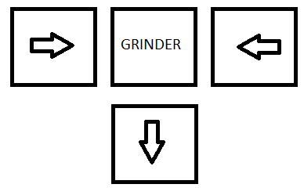

**Level 3:**

This level should introduce the brewer, by placing it in the level, with two conveyors and the grinder, to show how they need to be linked together, and how the brewer takes grounded up ingredients and produces the potion. (Shown Below). The output for this level will be the strength potion, and the initial screen can pop up, showing the player what the potion is called. No new buttons need to be shown yet, as no new machines will be shown in this section.

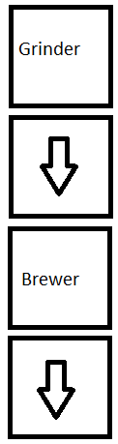

**Level 4:**

This is the final level of this section and should be a small test on what the player has learnt so far. The level will be completely empty, apart from the inputters and the mayor will pop up at the start, asking for the strength potion, by encouraging the player to use the tools they have learnt so far. The potion is the output for this level and should follow the two ingredients to the inputter with the ground up product being put into the brewer to make the potion, which gets carried into the output. When the level is completed, the mayor could pop up, with an encouraging message, praising the player for completing the level.

The next section will be focussed on fully explaining how the brewer works, building towards creating more complicated potions that require the brewer to take in 3 ground up ingredients, to make the potion. The section after that should focus on the oven, as this is a less intensive machine to learn, which the player will appreciate, as the brewer is the most complex machine.